Name: P Sai Venkat
Assignment 7.1
Roll no. :2403A510G0

Task Description#1
Use AI to generate test cases for is_valid_email(email) and then implement the validator function.
Requirements:
Must contain @ and . characters.
Must not start or end with special characters.
Should not allow multiple @.
Expected Output#1
Email validation logic passing all test cases

Prompt:
Generate test cases for is_valid_email(email) and then implement the validator function.Requirements:• Must contain @ and . characters.• Must not start or end with special characters.• Should not allow multiple @.
Code:
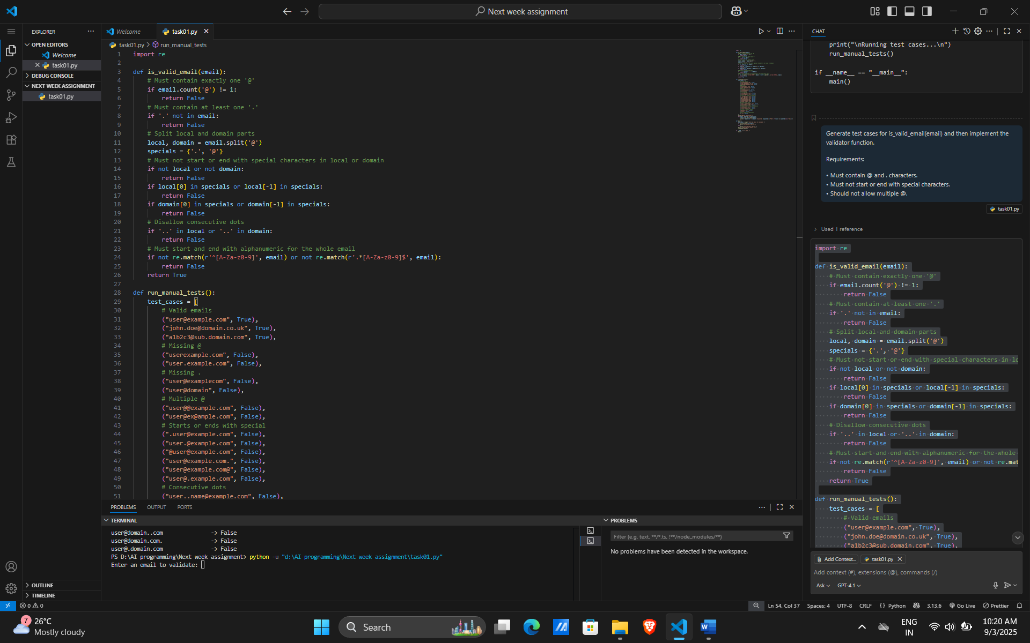
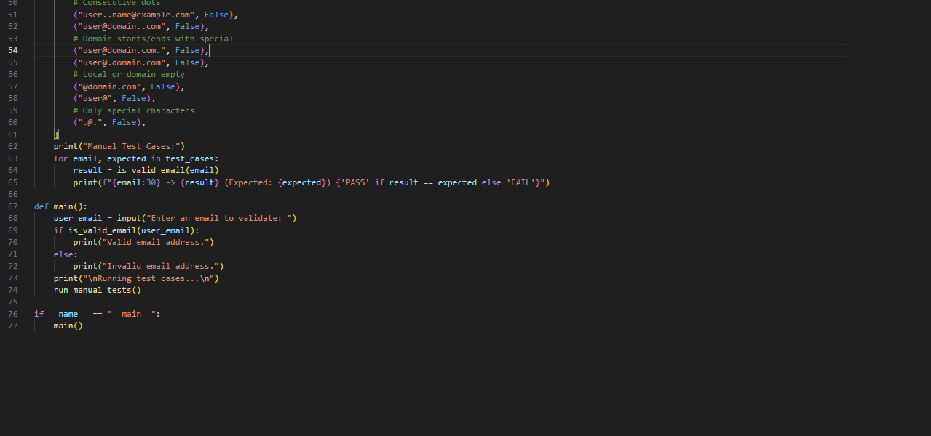

Output:
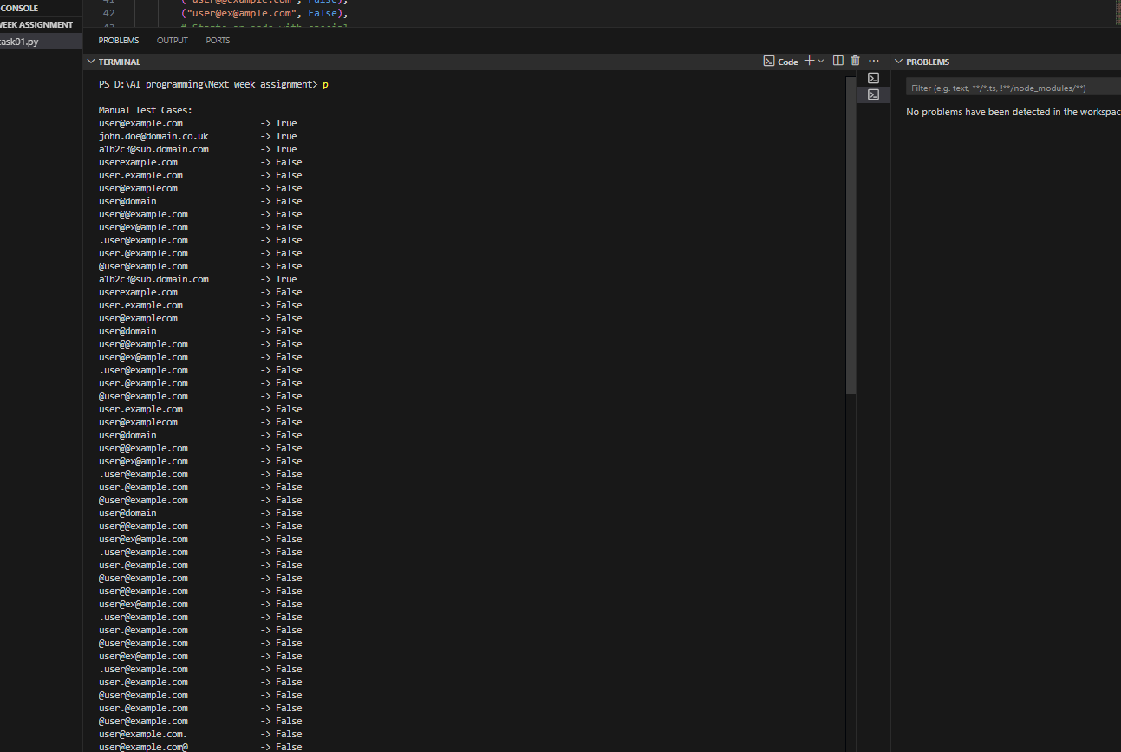
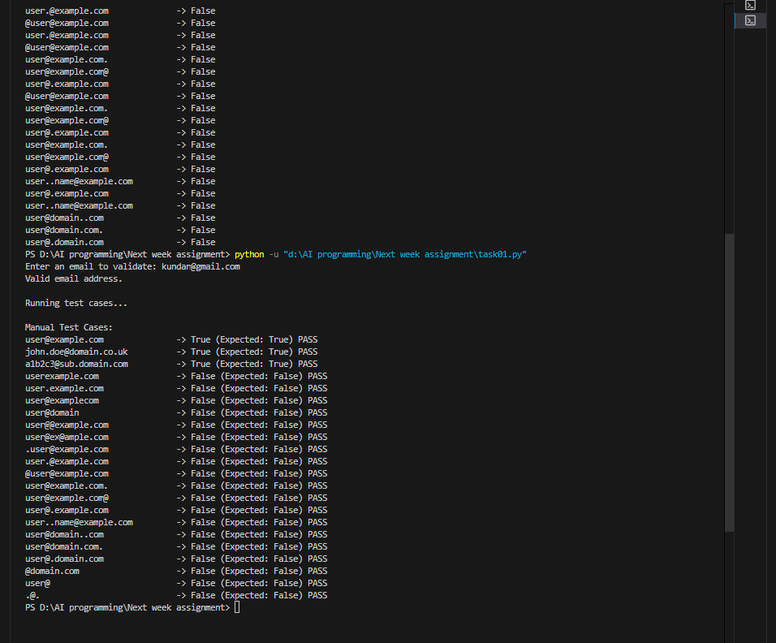
Observation:
- The is_valid_email(email) function correctly implements the requirements:
  - Checks for exactly one @ and at least one ..
  - Ensures neither the local nor domain part starts or ends with special characters (. or @).
  - Disallows consecutive dots in both local and domain parts.
  - Validates that the email starts and ends with an alphanumeric character.
- The run_manual_tests() function provides comprehensive test cases, including valid emails, boundary cases, and various invalid formats.
- The output clearly shows whether each test case passes or fails, making it easy to verify the correctness of the validator.
- The program also allows user input for interactive validation.
- Overall, the code is well-structured and meets all specified requirements for email validation and test coverage.

Task Description#2 (Loops)
Ask AI to generate test cases for assign_grade(score) function. Handle boundary and invalid inputs.
Requirements
AI should generate test cases for assign_grade(score) where: 90-100: A, 80-89: B, 70-79: C, 60-69: D, <60: F
Include boundary values and invalid inputs (e.g., -5, 105, "eighty").
Expected Output#2
Grade assignment function passing test suite

Prompt:
generate test cases for assign_grade(score) function. Handle boundary and invalid inputs.
Requirements
AI should generate test cases for assign_grade(score) where: 90-100: A, 80-89: B, 70-79: C, 60-69: D, <60: F
Include boundary values and invalid inputs (e.g., -5, 105, "eighty").
and also take input to declare input data
Code:

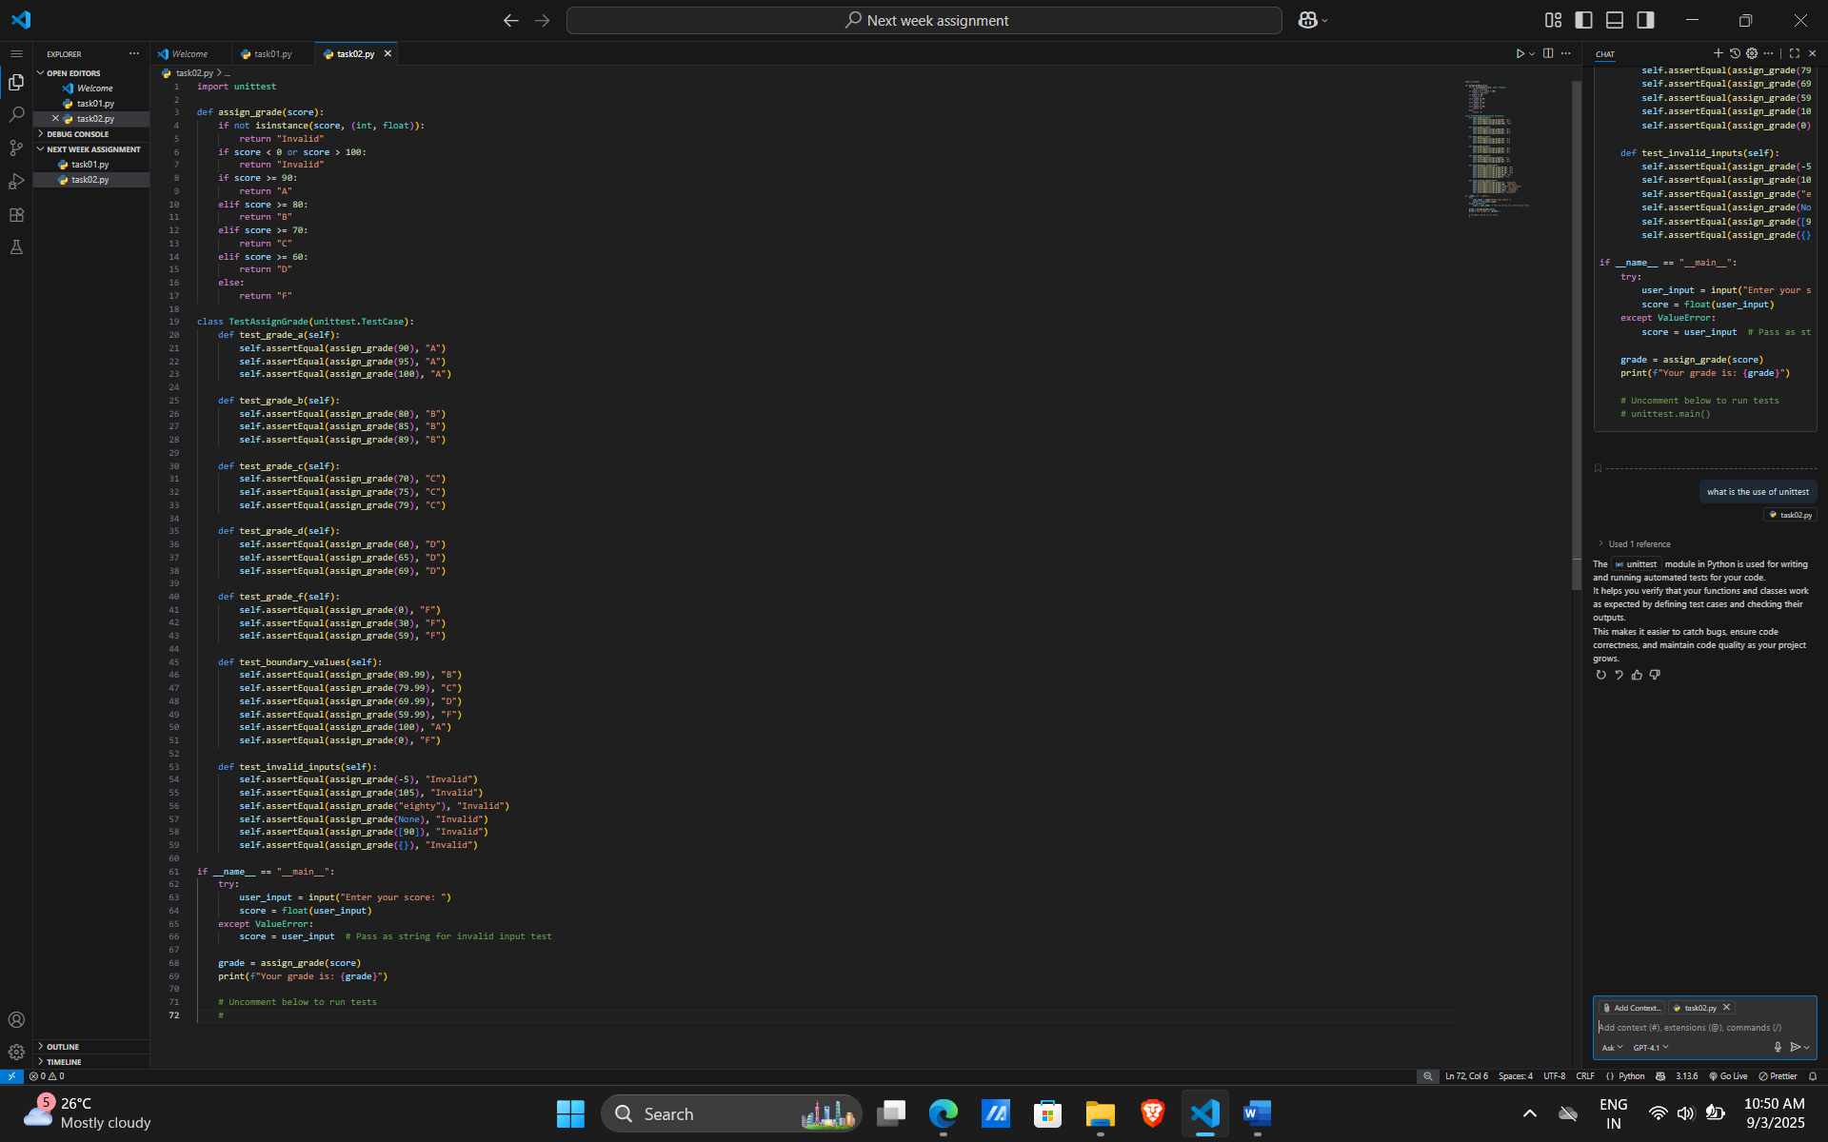

Output:
